HACETTEPE UNIVERSITY
Department of Computer Engineering

Fuzzy Modelling
Laboratory

Furkan Simsekli
5th Semester
Turkey

Academic Year 2023/2024

Exercise 4

Write a script to calculate the product and algebraic product of fuzzy sets A and B, which are described using trapezoidal membership functions:

C1 – green C2 – magenta C3 – blue
Z1 – continous line Z2 – continous line Z3 – continous line
line char “x”

K4 – black
Z4 - continous line
line char “*”

DS = 0.1 R=[0, 6]

Draw the membership functions µ_{A}(x), µ_{B}(x), µ_{C}(x) and µ_{D}(x) on one graph in the range of R. Use the following colours µ_{A}(x) – C1, µ_{B}(x) – C2, µ_{C}(x) – C3, µ_{D}(x) – C4, and continuous lines for each function and line characters Z1, Z2, Z3, Z4.

Sign the membership functions in the following way: µ_{A}(x) – MFA, µ_{B}(x) – MFB, µC(x) – MFC, µD(x) – MFD. Use a DS discretization step.

Write the equations describing the support and the power of a fuzzy set. Determine the support of the fuzzy sets: supp(C), supp(D) and the power of the fuzzy sets: card(C), card(D).

Solution

% product and algebraic product
x1=[0:0.1:2]
y1=0*x1
x2=[2:0.1:4]
y2=1/2*x2-1
x3=[4:0.1:6]
y3=0*x3+1

xa=[x1 x2 x3]
ya=[y1 y2 y3]

x4=[0:0.1:2]
y4=0*x4+1
x5=[2:0.1:4]
y5=-1/2*x5+2
x6=[4:0.1:6]
y6=0*x6

xb=[x4 x5 x6]
yb=[y4 y5 y6]

p=min(ya,yb)
ap=ya.*yb

% plot the curves
plot(xa,ya,'g',xb,yb,'m',xa,p,'b-x',xa,ap,'k-*')
grid on
legend('MFA','MFB','MFC','MFD')

% axis, line width, font size
set(gca,'fontsize',16)

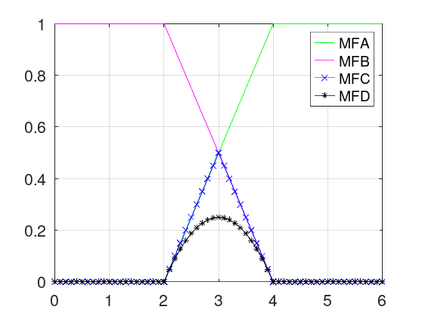
Figure 4.1: The membership functions MFA, MFB and the product MFC and the algebraic product MFD.

support(C) = {2.1, 2.2, 2.3, 2.4, 2.5, 2.6, 2.7, 2.8, 2.9, 3.0, 3.1, 3.2, 3.3, 3.4, 3.5, 3.6, 3.7, 3.8, 3.9}

support(D) = {2.1, 2.2, 2.3, 2.4, 2.5, 2.6, 2.7, 2.8, 2.9, 3.0, 3.1, 3.2, 3.3, 3.4, 3.5, 3.6, 3.7, 3.8, 3.9}

% calculate cardinal
cardC=sum(p)
cardD=sum(ap)

card(C) = 5.0000

card(D) = 3.3250

